33.8 (a)

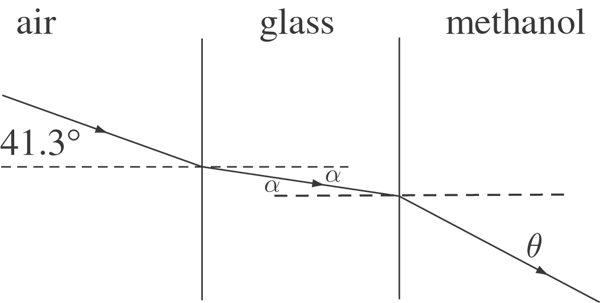

Apply Snell’s law at both interfaces.

At the air-glass interface:
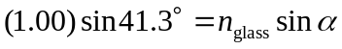
At the glass-methanol interface:
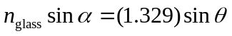 (2)

Combine (1) and (2):
